Patient Information Sheet 3T Multiparametric MRI

Imaging of the Prostate has improved significantly over the last 3 years and is now used routinely in the diagnosis and staging of prostate cancer. Manchester Urology use the latest 3 Tesla MRI machines and Multiparametric techniques to provide the most accurate imaging of the prostate. These MRI scans are reported by dedicated Uroradiologists with expertise in reporting Prostate MRI.

Use of MRI before prostate biopsy
Biopsies identify cancer within the prostate, but it is also important to know whether any cancer has spread beyond the confines of the gland into the surrounding tissue. The latest guidelines from the European Association of Urology highlight magnetic resonance imaging (MRI) as 'the most accurate non-invasive method' of identifying so called 'locally advanced' prostate cancer. It is important to know whether any cancer has spread to the surrounding tissue as it has an impact on the type of treatment you may be recommended.
Although MRI scans may be performed at any time before definitive treatment, there are several reasons why it may be best performed before biopsy:
- Biopsies create 'artifact' within and around the prostate gland due to bleeding which may persist for several months. These make interpretation of the MRI images more challenging.
- MRI may be helpful in localizing cancer within the prostate gland itself.
- Multiparametric MRI can help to identify focal abnormal areas within the prostate and often help to grade their significance using a PIRADS scoring system. This can then be used in the latest MRI – US Fusion Transperineal Targeted Prostate Biopsy techniques.
Latest MRI Techniques

Until recently MRI of the prostate was limited in its ability to distinguish between different problems. Older less powerful machines did not give adequate definition and standard protocols did not help differentiate between benign and cancerous changes.
The development of the 3 Tesla machines has enhanced the image quality so that the different tissue planes can be looked at more closely enabling the uroradiologists to stage prostate cancer more effectively.
Advanced protocols and the introduction of contrast have also allowed more accurate differentiation between benign and cancerous changes. These include the introduction of Dynamic Contrast Enhancement (DCE), ADC Mapping and Diffusion Weighted Imaging (DWI), all of which are available to the Manchester Urology Consultants and Uroradiologists.
The advances in MRI techniques have significantly improved the investigation and management of patients concerned about prostate cancer and this non invasive test is often used before prostate biopsies are considered.
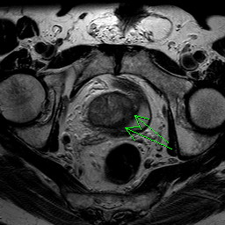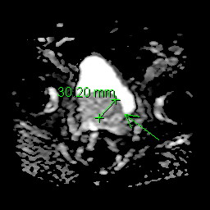

The MRI Scanner

The MRI scanner uses a strong magnetic field to produce images of the body and although it is a very safe procedure, there are certain things which can interfere with MRI. No specific preparation is required before, you will be asked questions about items which can interfere with MRI, such as:
•Do you have a pacemaker or have you ever had any operations to your heart?
•Have you ever had any operations to your head?
•Have you had any operations at any time to other parts of your body?
•Do you suffer from any kidney or liver problems?
•Have you any joint/ limb replacements or any implants?
•Have you ever had any metallic fragments in your eyes? (Particularly from an engineering or DIY accident?)
•Have you ever had any injury involving bullets or shrapnel?
•Have you ever had cosmetic surgery or tattoos?
•Are you wearing a hearing aid or a removable metal dental plate?
If the answer is ‘yes’ to any of the above questions, it does not necessarily exclude you from having an MRI scan, but it is important that you tell us so that the options can be discussed. We will be happy to provide you with further information if you are unsure about anything.

How do I get an MRI scan?

Following a consultation, PSA blood test and digital rectal examination your Manchester Urology Consultant will advise on whether an MRI scan is indicated. You will then be referred to one of the centers with 3T Multiparametric MRI capabilities.

When will the results be available?

Approximately 5 days after the scan you will be seen back in the clinic with the result of the MRI, and the Manchester Urology Consultant will go through all of the results to see if a biopsy is required. If a biopsy is required then the MRI scan will help determine the type of biopsy. This includes Transperineal Template Prostate Biopsies, Transperineal MR Fusion Targeted Prostate Biopsies or a combination of both.

